Cartoonizer Project

# What is the Cartoonizer?

The Cartoonizer is a Python program that transforms real-world photographs into cartoon-style images. It mimics the artistic style of cartoons by:

1. Simplifying complex colors into a limited palette
2. Highlighting bold, clean outlines
3. Adding subtle sketch-like textures

# Content

What is the Cartoonizer? 1

Content 1

Step by Step Explanation 3

1.Import Libraries 3

2.Initialization and UI Settings 3

__init__(self, root) 3

configure_styles(self) 4

create_widgets(self) 4

3.Core Image Processing 5

process_image(self) 5

Edge Detection: 5

Combine Two Edges 5

Refine Edges 6

TColor Simplification 6

Smoothing & Edge Preservation 6

Cartoon Effect 6

Display & Save Results 7

Error handle 7

4. Utility Functions 7

update_k_label(self) 7

toggle_edge_display(self) 7

update_result_display(self) 7

save_image(self) 8

**Overall Output** 9

**Conclusion** 11

**Reference** 11

# Step by Step Explanation

## 1.Import Libraries

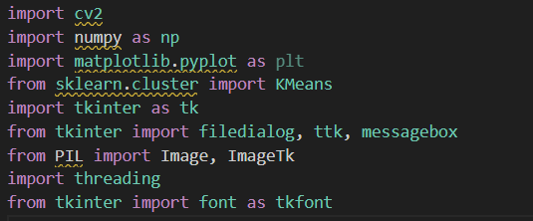

* 1. cv2 (OpenCV) – it handles the image processing tasks
  2. np (NumPy) – manages numerical operations and arrays
  3. matplotlib.pyplot – for displaying images
  4. sklearn.cluster.KMeans – reducing color complexity
  5. tkinter – let the user choose their own image file by opening a file dialog
  6. PIL.Image, PIL.ImageTk —Image processing is compatible with Tkinter
  7. Threading—Prevent the interface from freezing during image processing.

## 2.Initialization and UI Settings

#### __init__(self, root)

Purpose: Initializes the application window and variables.

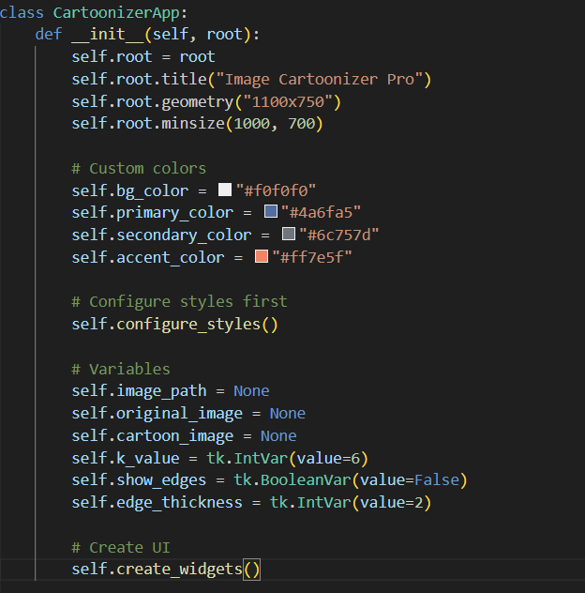

Sets window title, dimensions, and minimum size constraints.

Defines color scheme (bg_color, primary_color, etc.).

Initializes critical variables (image_path, k_value, show_edges).

Calls configure_styles() and create_widgets() to build the interface.

#### configure_styles(self)

Purpose: Configures ttk widget styles.

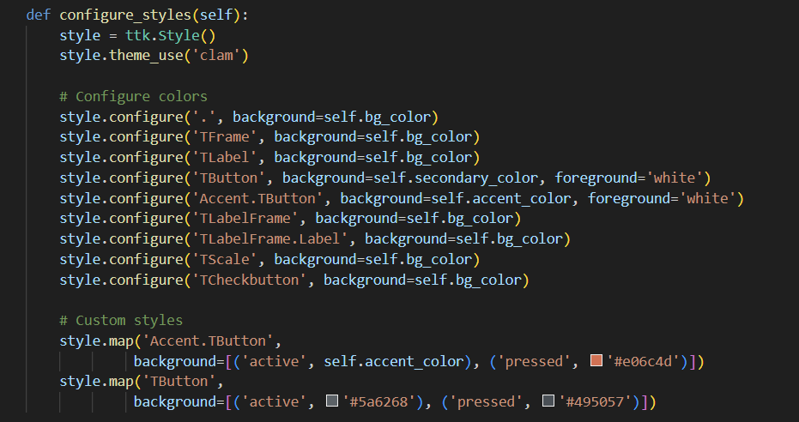

Uses the clam theme for a modern look.

Customizes colors for buttons, labels, and frames.

Defines Accent.TButton for prominent action buttons (e.g., "Cartoonize!").

#### create_widgets(self)

Purpose: Constructs the GUI layout.

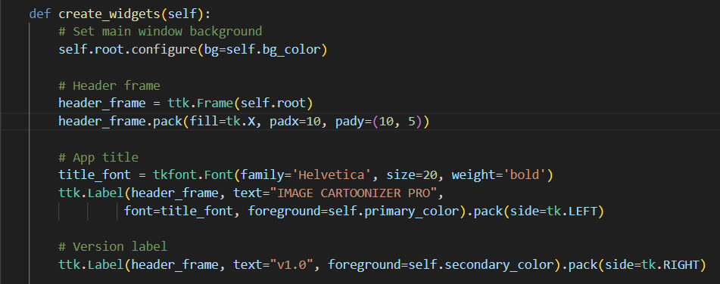

Left Panel (Controls):

File selection button (load_image).

Sliders for parameters (k_value, edge_thickness).

Checkbox to toggle edge display (show_edges).

Action buttons ("Cartoonize!", "Save Result").

Right Panel (Images):

Two labeled frames for original/cartoonized images.

Uses ttk.Label to display images.

Status Bar: Shows operation progress (e.g., "Processing...").

## 3.Core Image Processing

#### process_image(self)

Purpose: Implements the cartoonization pipeline.

Edge Detection:

The goal in this section is to highlight the outlines like a cartoon

The first line converts the image to grayscale and second line reduces the noise, the larger value, the more blur it gets.

Combine Two Edges

The 37th line detect the sharp edges and 38th merge both edge types.

Adaptive Threshold:

block_size = 11 : pixel neighbourhood size for threshold calculation

c = 2 : constant subtracted from the mean

Canny Edge Detector:

minVal = 30, maxVal = 100 : weaker edges below minVal are discarded and stronger edges above maxVal are being kept

##### Refine Edges

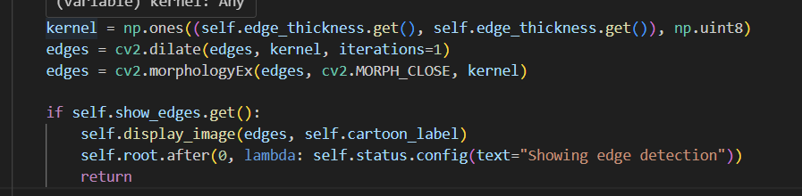 Ensures edges are continuous and visually prominent in the final cartoon effect.

User-adjustable via the edge_thickness slider (default: 2px).

Allows users to preview and debug edge detection separately.

Helps adjust edge-related parameters (edge_thickness) interactively.

##### TColor Simplification

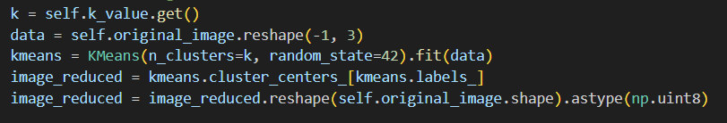Flatten color region using k-means clustering..

Reshape image into 2D array of pixels (each row is a pixel's RGB).

Perform k-means clustering to reduce color palette.

Reconstruct image using cluster centers.

##### Smoothing & Edge Preservation

 Apply bilateral filter to smooth while preserving edges.

##### Cartoon Effect



Cartoon Styling.

Apply black edges to the smoothed image.

##### Display & Save Results

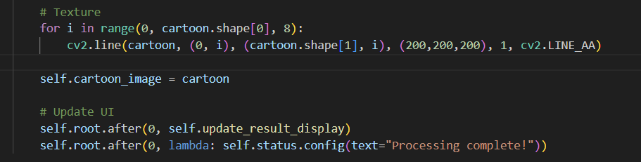 Draw light gray horizontal lines every 8 pixels.

Store final result.

##### Error handle

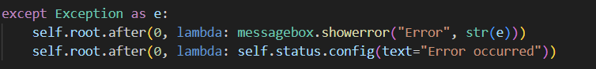

## 4. Utility Functions

#### update_k_label(self)

Purpose: Updates the K-value slider label in real time.

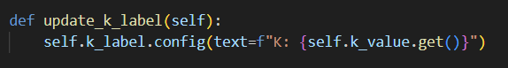

#### toggle_edge_display(self)

Purpose: Toggles between edge-only and full cartoonized views.

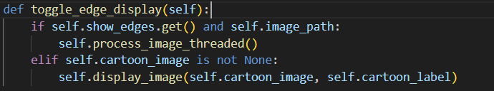

Controlled by the show_edges checkbox.

Calls process_image_threaded to regenerate the display.

#### update_result_display(self)

Purpose: Refreshes both image displays.

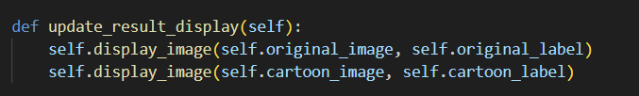

Ensures the original and processed images are synced.

#### save_image(self)

Purpose : Saves the cartoonized image to a user-specified file location.

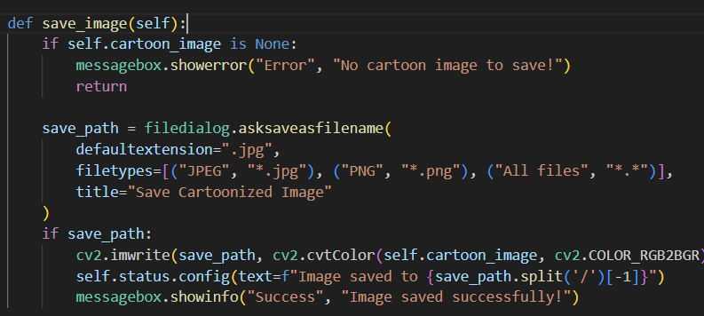

Ensures users can export results without technical hurdles.

Maintains OpenCV’s BGR convention while internally using RGB for display.

# **Overall Output**

**Step 1: Select Your Photo**

Click “Select Image” to open a file dialog, choose the picture you want to cartoonize, and load it. You’ll see the original image appear on the left.

**Step 2: Adjust Color Regions (K)**

Slide “Color Regions (K)” to pick how many color clusters the algorithm uses. Lower K gives broad flat colors; higher K preserves more detail.

**Step 3: Set Edge Thickness**

Move “Edge Thickness” to control how bold the outlines become. Higher values yield thicker, graphic lines; lower values are subtler.

**Step 4: Preview Edge Detection (Optional)**

Tick “Show Edge Detection” to view just the edge map. This helps you fine-tune outline settings before blending them with colors.

**Step 5: Generate the Cartoon**

Click “Cartoonize” to run the transformation. The app applies edge detection, color clustering, and smoothing, then shows the result on the right next to your original.

**Step 6: Save Your Result**

When you’re satisfied, click “Save Result,” choose a folder and filename in the dialog, and export the final cartoon image.

# **Conclusion**

This application demonstrates a well-structured approach to image cartoonization, balancing functionality and usability. Its modular design (e.g., separating UI, processing, and file I/O) makes it easy to extend. The next potential steps could include:

Integrating deep learning models (e.g., GANs) for more artistic styles.

Adding undo/redo functionality for parameter experimentation.

Deploying as a web/desktop app (e.g., using PyQt or Flask for broader access).

Overall, the code is production-ready for basic use cases and serves as an excellent foundation for further development in creative image processing.

# **Reference**

We referred to the Cartoonify-Image project by Abdesol on GitHub as a guide for implementing parts of our image-processing pipeline.

**Abdesol. (2019). *Cartoonify-Image* [Computer software]. GitHub.** [**https://github.com/Abdesol/Cartoonify-Image.git**](https://github.com/Abdesol/Cartoonify-Image.git)